School District of Bonduel

Academic and Career Planning (ACP) Plan
Completed 2017--Updated 2023

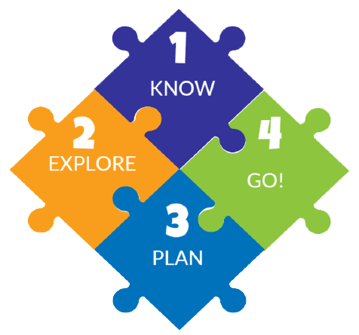
Academic and Career Planning, or ACP, is a student-driven, adult supported process in which students create and cultivate their own unique and information-based visions for post-secondary success, obtained through self-exploration, and the development of career management and planning skills. The Wisconsin Department of Public Instruction (http://dpi.wi.gov/acp) in the PI26 legislation requires public school districts to provide academic and career planning services to students in Grades 6 through 12 beginning in the 2017-2018 school year. These new academic and career planning requirements connect school districts' education for employment plans and programs to the new academic and career planning requirements.

In the School District of Bonduel, we are proud to be implementing Academic and Career Planning. We have always had ACP in place, but now it’s more formalized for all. ACP is a 4-part process of KNOW, EXPLORE, PLAN, AND GO which students develop throughout Middle School and High School. It is an integral part of our Comprehensive School Counseling conferencing model.

 | Counseling | Classroom | Other
6th | - Academic Support  - Communication and Collaboration with Families | - Xello  - Study Skills Exploratory  - Testing, measuring and number sense skills  - Career Exploration in Social Studies and Music  - Academic Support  - Communication and Collaboration with Families  - Exploratory classes | - Wisconsin Forward Exam  - Co-Curricular Opportunities
7th | - Leadership Exploratory  - Academic Support  - Communication and Collaboration with Families | - Xello  - Family Research Project  - Organization Skills  - Student-led PowerPoint  - Career Exploration in ELA  - Academic Support  - Communication and Collaboration with Families  - Exploratory classes | - Wisconsin Forward Exam  - Co-Curricular Opportunities
8th | - Careers Exploratory  - Xello -- ALL Assessments/Surveys  - Career Classroom Presentations  - Freshman Course Selection/4-year plan  - Academic Support  - Communication and Collaboration with Families | - Xello  - Career Exploration in ELA, Civics and Math  - Self-Advocacy Curriculum  - Mock Trial  - Academic Support  - Communication and Collaboration with Families  - Exploratory classes | - 8th Grade Career Fair  - Wisconsin Forward Exam  - Agriculture Exploratory Day  - Co-Curricular Opportunities

 | Counseling | Classroom | Other
9th | - Program  - 4-year planning  - College Introduction  - Portfolio and Profile/Resume Development  - Mentoring  - Academic Support  - Communication and Collaboration with Families | - Course Selection, including CTE options  - Career/College Pathways  - Academic Support  - Communication and Collaboration with Families  - Subject Specific Career Posters | - Xello  - Success Day--career and college exploration  - Pre-ACT  - Co-Curricular Opportunities
10th | - Review 4-year plan  - Portfolio and Profile/Resume Review and Revisions  - Academic Support  - Communication and Collaboration with Families | - Course Selection, including CTE and AP options  - Career/College Pathways  - Academic Support  - Communication and Collaboration with Families | - Xello  - Success Day--career and college exploration  - Pre-ACT  - Wisconsin Forward Exam  - Co-Curricular Opportunities
11th | - Review 4-year plan  - Portfolio and Profile/Resume Review and Revisions  - Scholarship Information  - College Rep Visits  - Military Recruitment Visits  - Academic Support  - Communication and Collaboration with Families | - Course Selection, including CTE, AP and Dual Credit options  - Career/College Pathways  - School Options including Early College Credit, Youth Apprenticeship, Start College Now  - Academic Support  - Communication and Collaboration with Families  - Subject Specific Career Poster | - Success Day--career and college exploration  - Xello  - ACT with Writing  - ASVAB  - PSAT  - Co-Curricular Opportunities
12th | - College Application and Assistance  - College Goal-Financial Aid Assistance  - Scholarship Application and Assistance  - College Rep Visits  - Military Recruitment Visits  - Academic Support  - Communication and Collaboration with Families | - Course Selection, including CTE, AP and Dual Credit options  - Career/College Pathways  - School Options including Early College Credit, Youth Apprenticeship, Start College Now  - Academic Support  - Communication and Collaboration with Families | - Resume creation/review  - Success Day--Mock interviews  - Xello  - ASVAB  - Co-Curricular Opportunities

